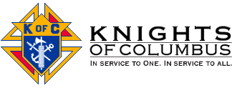

Father Diamond Council 6292 Christmas Party

Saturday, December 15, 2007 6:00 PM

St. Leo the Great Catholic School Gymnasium

$15 per person

Council Provides:

Main Dishes, Potatoes, Vegetable, Dessert,
Beer, Wine, Soda, Juice.

Please Bring Either:

Appetizers

or

Holiday Spirits

to share.

Please RSVP to Nelson Clinch at:

(703) 385-2146

or

clinch5va@yahoo.com.

