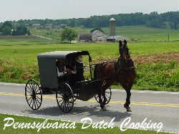
St. Andrew the Apostle & St. Leo the Great Parishes Trip

Pennsylvania Dutch Country

Plan now to join Fr. Kelly at the farm of his Amish friends for lunch, followed by a tour and shopping at the National Christmas Center, Paradise, PA
THURSDAY, September 26, 2013

The bus will leave St. Leo the Great Catholic Church parking lot, (3700 Old Lee Highway, Fairfax, VA 22030), promptly at 7:30am and return at approximately 7:30pm

The cost is $65.00 per person and includes transportation, lunch, museum tour, gratuities and fun

Seating is limited and will be reserved on a first-come-first-served basis
- - - - - - - - - - - - - - - - - - - - - - - - - - - - - - - - - - - - - - - - - - - - - -
I _____________________________ will participate in the Parish Trip to
Print Name for Name tag

Pennsylvania Dutch Country on Thursday, September 26, 2013. In order to hold my seat, my $65.00 fee made payable to “Columbiettes” is attached to this registration form.

Contact information:
Address__________________________________________________

Cell Phone number________________________________________

Email address ____________________________________________

